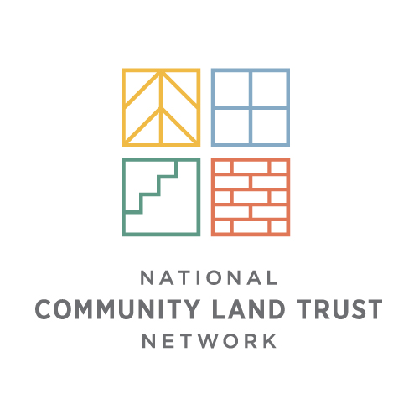
Permanently Affordable Homeownership
& Community Land Trusts
Sustainable models that use a one-time public investment to
create a permanently affordable home

What are CLT and PAH Programs?
Community Land Trusts (CLTs) are nonprofit organizations that provide lasting community assets and permanently affordable
In 46 states:

>200 CLTs
>600 PAH programs
> 150,000 homes
housing opportunities for lower-income families. CLTs are best
known for their permanently affordable homeownership (PAH) programs. Along with CLTs, some Community Development Corporations (CDCs), Community Development Financial Institutions (CDFIs), Habitat for Humanity affiliates, and government-based inclusionary zoning programs have
PAH programs.
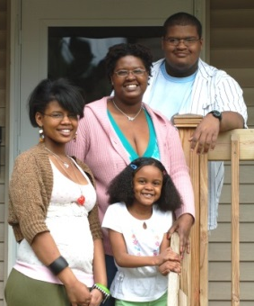
How Do They Work?
A one-time public investment is used in a self-sustaining way to keep homes forever affordable to families with modest incomes. PAH programs invest public funds into a property to make home purchase affordable for a lower-income family. The program supports the family to attain and sustain homeownership. In return, the homeowner agrees to sell the home at an affordable price to another lower-income homebuyer in the future. Consequently, the family is able to successfully own a home and build wealth, while the program is able to preserve the public’s investment in the home permanently to help family after family.

% of Mortgages that are 90+ Days Delinquent
or in Foreclosure Proceedings
(Thaden 2011)
What Do They Accomplish?
- Increase access to successful homeownership among
lower income and minority families.

- Buffer the adverse impacts of gentrification
by providing a stock of housing that remains
affordable.

- Stabilize neighborhoods by increasing owner
occupancy, promoting residential stability,
preventing foreclosures, and maintaining homes
in good condition.
TEXT: WHAT DO YOU WANT THE ELECTED OFFICIAL TO DO?
Provide background information on the issue that you will be discussing in the meeting. Explain why the issue is broadly important.
Homeowner Story:

Use a homeowner (or other) story to highlight how the issue impacts real people in a real community. This story should be directly related to the issue and the ask.

Insert Resident Photo/Name

Our Issue
Drill down and explain how the issue is impacting your organization or program. If you have a chart or an image that helps make your case, include it here.

Our Ask
This is what you would like the elected official to do on your behalf. It should be phrased as a request. Your “Asks” should be timely and actionable.

